Here's the mathematical representation of the logistic function:

σ(t)=et/(1+et)σ(t)=et/(1+et)

The logistic function is broken up into two key parts:

* The exponential transformation, transforming all values to be positive:

et

* The normalization transformation, transforming all values to range between 0  and 1:

t/(1+t)

The exponential transformation and the normalization force the output values to be squeezed between 0 and 1. If you plot just the exponential part, the output values won't be limited to the range of 0 to 1:

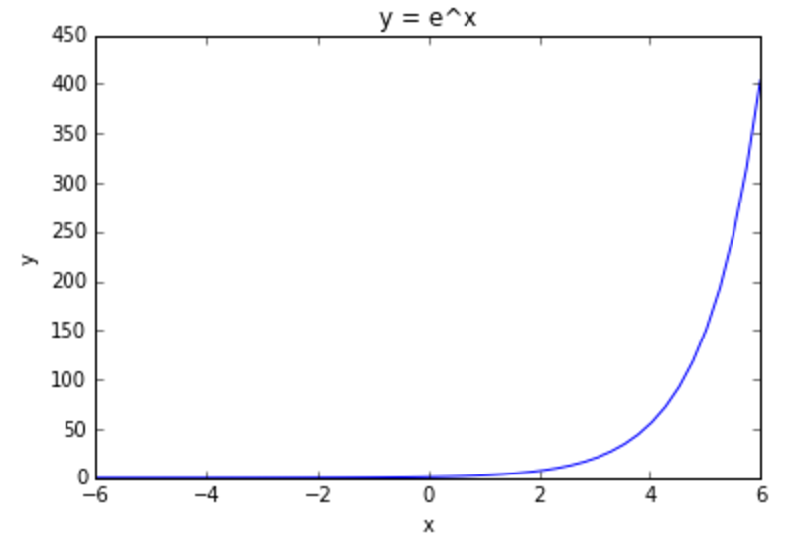

Normalization alone isn't sufficient since it struggles at constraining negative values:

